Distance measuring (Chaining) with steel band or cloth tape

Chain - Unit of length usually understood to be Gunter's chain, but possibly variant by locale. The name comes from the heavy metal chain of 100 links that was used by surveyors to measure property bounds. (1 link = Unit of length equal to 1/100 chain (7.92 inches) or 0.201168 metres)

Chaining
Historically a chain made up of 100 links was used for distance measurement, and this terminology has stayed with surveying ever since. Chainage is a bit of jargon that now applies to measurement with a steel band, fibreglass tape, or a cloth tape; in fact any item that measures the distance directly in the field.

Unfortunately, chainage is prone to errors and mistakes.

Corrections for Chainages
Listed below are several corrections that can be applied to chained distances to minimize systematic errors and to correct for the effects of the physical environment of the measurement process.

- Temperature
Most materials expand and contract with temperature change, and this effects taped distances. If a tape has stretched due to heat it will read shorter than it would at its normal (or standard) temperature.

- Catenary (Sag)
If the tape cannot be supported for its length then it will hang freely under the influence of gravity. The shape the tape will take is known as a catenary and can be determined mathematically.
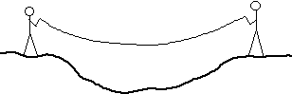

Slope
All plan distances are always quoted as horizontal distances, therefore any distance not measured on the horizontal will need to be corrected for slope. Slope correction must always be considered, and either eliminated in the field or mathematically compensated.
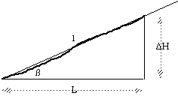
a. Reduction by slope angle
The horizontal distance is given by
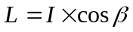
- Reduction by differences in height
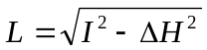

- Tension
A tape is a given length when pulled with a certain tension. If the tension changes then so does the tape length.

